Low-Level Design (LLD) — Reason Module
Attribute | Value
Module | Reason (System Config Master)
Menu path | SYSTEM CONFIGURATION → Reason
Landing page | reasons.php
Application | Complaint / Dealer Portal
Stack (target) | Core PHP + MySQL (PDO)
Stack (current repo) | Core PHP + PostgreSQL via PDO
Document version | 1.0
Access | System Admin only (role id 6) — no RBAC module slug
Architecture | Shared SCM stack ($scmType = 'reason')

â”€â”€â”€â”€â”€â”€â”€â”€â”€â”€â”€â”€â”€â”€â”€â”€â”€â”€â”€â”€â”€â”€â”€â”€â”€â”€â”€â”€â”€â”€â”€â”€

1. Module Overview

1.1 Purpose
System Administrators maintain Reason options in reason_masters for Spare Parts Consumption line items. The module is a thin SCM wrapper sharing system_config_master_* pages, helpers, APIs, and JS. Consumers store the selected name string on each spare-parts item (not an FK id). Service Log and Installed Base reuse the same options only inside their Add Spare Parts modals.

1.2 Scope
In scope | Out of scope
List / Add / Edit / Details / Soft-delete | Complaint Entry master field
Active / Inactive status | Service Log header field (modal SP items only)
Case-insensitive name uniqueness | Hard delete
Create abuse / rate-limit guard | Cascading rename/delete to spare-parts items
Active names for Spare Parts Select2 | Other SCM types

1.3 High-level architecture
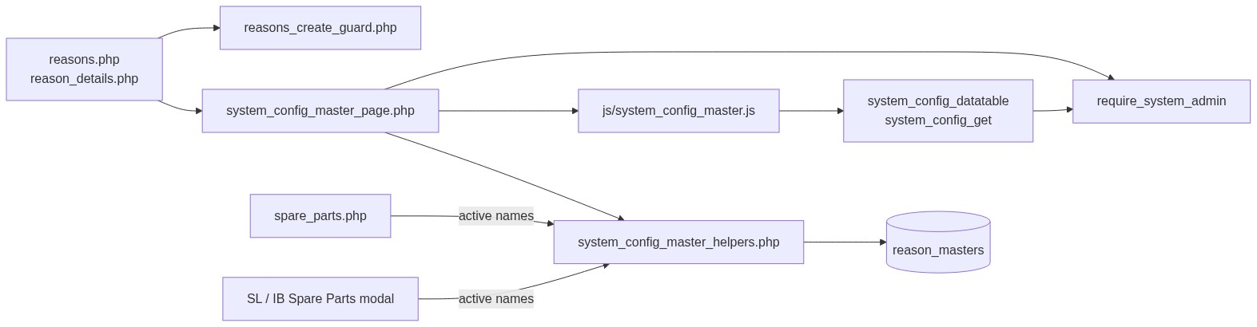
Figure 1 — High-level architecture
â”€â”€â”€â”€â”€â”€â”€â”€â”€â”€â”€â”€â”€â”€â”€â”€â”€â”€â”€â”€â”€â”€â”€â”€â”€â”€â”€â”€â”€â”€â”€â”€

2. Functional Requirements
ID | Requirement | Priority
FR-01 | System Admin can open Reason list (DataTables) | Must
FR-02 | Create reason with name and status | Must
FR-03 | Edit via inline slide-down form | Must
FR-04 | Soft-delete; hide from list | Must
FR-05 | Unique name among non-deleted (case/trim-insensitive) | Must
FR-06 | Filter / search list; status active/inactive | Should
FR-07 | View read-only details + audit fields | Should
FR-08 | Throttle / rate-limit create requests | Should
FR-09 | Client validate.js for name + status | Should
FR-10 | Expose active names to Spare Parts (and SL / IB SP modals) | Must

â”€â”€â”€â”€â”€â”€â”€â”€â”€â”€â”€â”€â”€â”€â”€â”€â”€â”€â”€â”€â”€â”€â”€â”€â”€â”€â”€â”€â”€â”€â”€â”€

3. User Roles & Permissions

3.1 RBAC module slug
None. Reason administration is gated by System Admin (SYSTEM_ADMIN_ROLE = 6), not a permission slug.

3.2 Permission matrix
Capability | Gate
All Reason admin pages | require_system_admin($obconn) (via SCM page)
SCM APIs with type=reason | admin_api_require_system_admin
Denied | Access denied. System Admin privileges required.

Pages (reasons.php, reason_details.php, delete_reason.php) are in rbac_admin_pages() and skip module RBAC; System Admin check is authoritative.

3.3 Page / API mapping
Resource | Gate
reasons.php | System Admin
reason_details.php | System Admin
delete_reason.php | System Admin
api/system_config_datatable.php?type=reason | System Admin API
api/system_config_get.php?type=reason | System Admin API

3.4 Consumer access
Spare Parts users need Spare Parts module permissions (separate). They only see active, non-deleted names via scm_get_active_names('reason') / spare_parts_reasons().
â”€â”€â”€â”€â”€â”€â”€â”€â”€â”€â”€â”€â”€â”€â”€â”€â”€â”€â”€â”€â”€â”€â”€â”€â”€â”€â”€â”€â”€â”€â”€â”€

4. Business Rules
ID | Rule
BR-01 | Soft-deleted rows excluded from list, get, uniqueness, and SP options.
BR-02 | Name unique among non-deleted: LOWER(TRIM(name)); edit excludes self.
BR-03 | Soft-deleted names may be reused on create (partial unique index).
BR-04 | Status must be active or inactive.
BR-05 | Inactive names stay in admin list but are not offered in Spare Parts.
BR-06 | Soft-delete / rename does not update existing spare_parts_consumption_items.reason values.
BR-07 | No “in use” check before soft-delete.
BR-08 | Create-only abuse guard: max 1/request; min 3s interval; max 20 creates / 15 min.
BR-09 | Edit requires existing non-deleted row.
BR-10 | created_by = current_username() on insert; created_at / updated_at timestamps.
BR-11 | Details/delete URL ids are base64_encode((string) id).
BR-12 | Create/update stay on page (no PRG). Delete redirects to list with session flash.
BR-13 | Spare Parts items store the name string, not reason_masters.id.
BR-14 | SCM type key is reason; table reason_masters; submit key submit_reason.
BR-15 | Master name max 100; item column is VARCHAR(50) — keep option names ≤ 50 for safe storage.
BR-16 | Reason is required per spare-parts line item (not header-only).

â”€â”€â”€â”€â”€â”€â”€â”€â”€â”€â”€â”€â”€â”€â”€â”€â”€â”€â”€â”€â”€â”€â”€â”€â”€â”€â”€â”€â”€â”€â”€â”€

5. Database Design

5.1 ER diagram
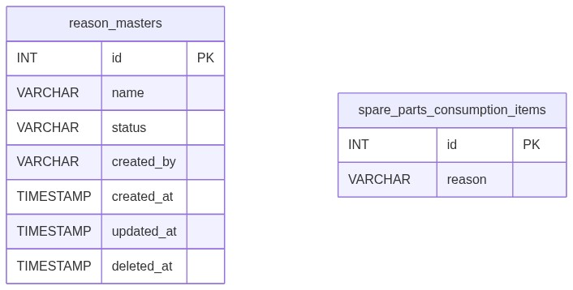
Figure 2 — Entity relationship diagram
Logical link (name string, not FK):
Figure 3 — Denormalized name link to Spare Parts items

5.2 Table: reason_masters
Column | MySQL type | Notes
id | INT UNSIGNED AUTO_INCREMENT | PK
name | VARCHAR(100) | Required; unique among non-deleted
status | VARCHAR(20) | active / inactive; default active
created_by | VARCHAR(100) | Creator username
created_at | TIMESTAMP | Insert
updated_at | TIMESTAMP NULL | Update / soft-delete
deleted_at | TIMESTAMP NULL | Soft-delete

Indexes (current repo): PK on id; partial unique on lower(trim(name)) WHERE deleted_at IS NULL; index on deleted_at.

5.3 Related tables
Table | Column | Role
spare_parts_consumption_items | reason VARCHAR(50) | Primary consumer (per item)

5.4 Reference / lookup sources
Source | Usage
scm_registry()['reason'] | Labels, pages, table, submit key
rbac_status_options() | Status <select>
scm_get_active_names('reason') | SP dropdown options
spare_parts_reasons() | Consumer wrapper

â”€â”€â”€â”€â”€â”€â”€â”€â”€â”€â”€â”€â”€â”€â”€â”€â”€â”€â”€â”€â”€â”€â”€â”€â”€â”€â”€â”€â”€â”€â”€â”€

6. API / Backend Design

6.1 Page endpoints
Endpoint | Method | Auth | Description
reasons.php | GET | System Admin | List + Add/Edit panel
reasons.php | POST submit_reason | System Admin | Create or update
reason_details.php?id= | GET | System Admin | Read-only details
delete_reason.php?id= | GET | System Admin | Soft-delete

Wrappers set $scmType = 'reason' and include shared SCM templates.

6.2 JSON APIs

POST api/system_config_datatable.php
Body/query includes type=reason. Server-side DataTables over reason_masters where deleted_at IS NULL.
{
"draw": 1,
"recordsTotal": 10,
"recordsFiltered": 2,
"data": [{ "id": "#1", "name": "...", "status": "...", "actions": "<html>" }]
}

GET api/system_config_get.php?type=reason&id=
Returns row for edit form population. System Admin API gated.

6.3 Supporting lookup APIs
N/A for admin UI. Spare Parts (and SL / IB SP modals) embed active names as JSON (#sparePartsReasonOptionsJson / #slSparePartsReasonOptionsJson) for Select2.

6.4 Core PHP responsibilities
File | Role
reasons.php | Create-guard hook + $scmType wrapper
includes/system_config_master_page.php | Shared list/form POST handler
includes/system_config_master_details_page.php | Shared details
includes/system_config_master_delete.php | Shared soft-delete
includes/system_config_master_helpers.php | Registry, validate, CRUD, options
includes/module_create_guards/reasons_create_guard.php | Create throttle / rate limit
includes/spare_parts_helpers.php | spare_parts_reasons() wrapper
includes/admin_access_helpers.php | System Admin gate

â”€â”€â”€â”€â”€â”€â”€â”€â”€â”€â”€â”€â”€â”€â”€â”€â”€â”€â”€â”€â”€â”€â”€â”€â”€â”€â”€â”€â”€â”€â”€â”€

7. Validation Rules

7.1 Server-side (scm_validate + uniqueness + create guard)
Field / rule | Message
Name empty | Reason name is required.
Name > 100 | Reason name cannot exceed 100 characters.
Status missing/invalid | Status is required.
Duplicate name | Reason name already exists. Please choose a different name.
Missing edit target | Reason not found or already deleted.
Create throttle | Please wait a few seconds before creating another record.
Rate limit | Create rate limit exceeded. You may create up to 20 records every 15 minutes...
Bulk payload | Too many records in a single request. A maximum of 1 record(s)...

Spare Parts consumer (per item N):
Spare part item N: Reason is required. / Spare part item N: Invalid Reason selected.

7.2 Client-side (js/system_config_master.js)
â€¢ validate.js: Name required + max 100; Status required (generic wording)
â€¢ Edit load failure: Failed to load record details.
â€¢ Success alert fades after 3s
â€¢ Status is native <select> (no Select2 on master)
â€¢ Consumer JS (spare_parts_items.js): Reason is required
â”€â”€â”€â”€â”€â”€â”€â”€â”€â”€â”€â”€â”€â”€â”€â”€â”€â”€â”€â”€â”€â”€â”€â”€â”€â”€â”€â”€â”€â”€â”€â”€

8. UI Screen Specifications

8.1 Listing — reasons.php
Element | Spec
Subtitle | Manage reason options for spare parts consumption.
Placeholder | e.g. PM
CTA | Add Reason / Cancel (#scmFormCard)
Grid | #scmTable — ID, Name, Status, Created At, Action
List title | Reason Masters List
Actions | View / Edit / Delete (confirm('Delete this record?'))
Icon | bi-list-check

8.2 Form panel
Fields: Name*, Status* (active / inactive).
Hidden: record_id, submit_reason, SCM type wiring via scm_page_js_config.

8.3 Details — reason_details.php
Name, status badge, created by, created/updated timestamps (shared record-details layout).

8.4 Modals / Select2
â€¢ No CRUD modals on master.
â€¢ Admin: native status select — no Select2.
â€¢ Consumers: Select2 on .spare-parts-reason-select (name="spare_parts_items[N][reason]"), placeholder Search reason.
â”€â”€â”€â”€â”€â”€â”€â”€â”€â”€â”€â”€â”€â”€â”€â”€â”€â”€â”€â”€â”€â”€â”€â”€â”€â”€â”€â”€â”€â”€â”€â”€

9. Database Flow

9.1 Create
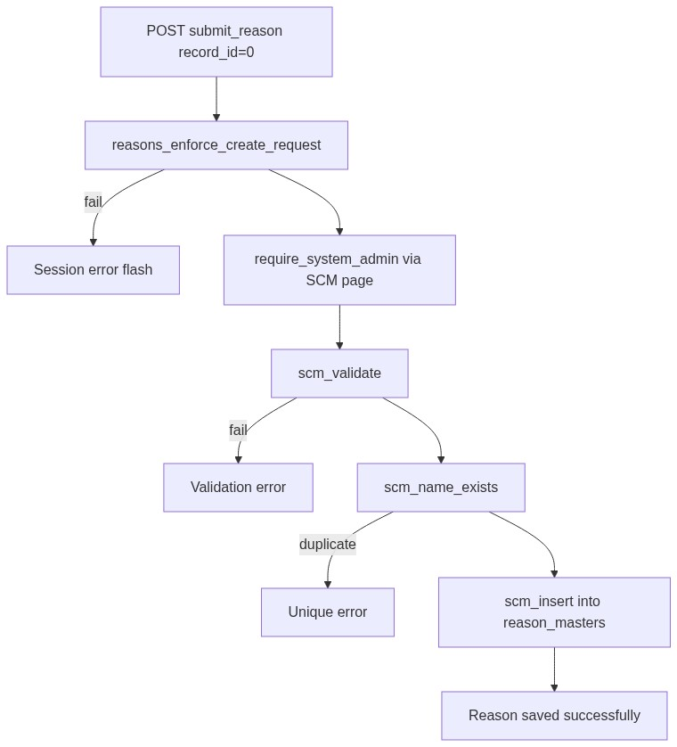
Figure 4 — Create database flow

9.2 Soft-delete
UPDATE reason_masters
SET deleted_at = CURRENT_TIMESTAMP,
updated_at = CURRENT_TIMESTAMP
WHERE id = :id
AND deleted_at IS NULL;

9.3 Active options for Spare Parts
SELECT name
FROM reason_masters
WHERE deleted_at IS NULL
AND status = 'active'
ORDER BY created_at ASC, id ASC;
â”€â”€â”€â”€â”€â”€â”€â”€â”€â”€â”€â”€â”€â”€â”€â”€â”€â”€â”€â”€â”€â”€â”€â”€â”€â”€â”€â”€â”€â”€â”€â”€

10. Sequence Diagram

10.1 Create reason
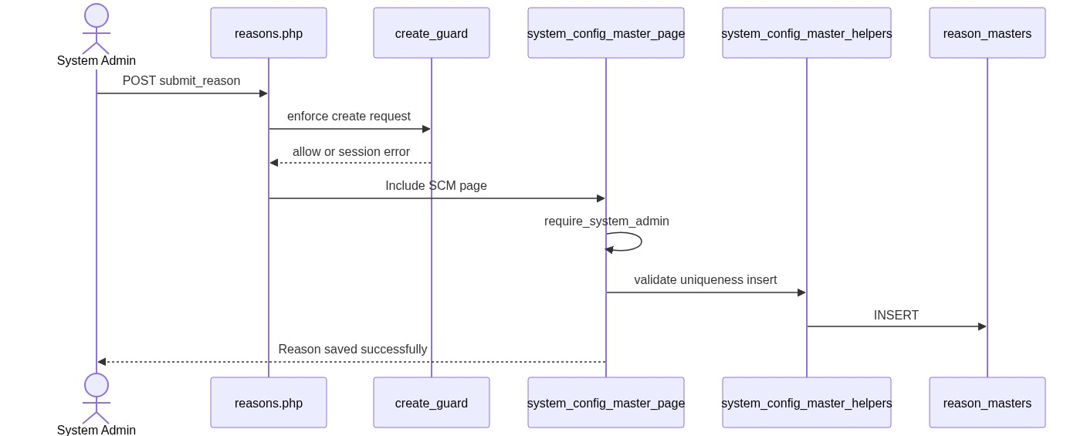
Figure 5 — Sequence: Create reason

10.2 Soft-delete and Spare Parts impact
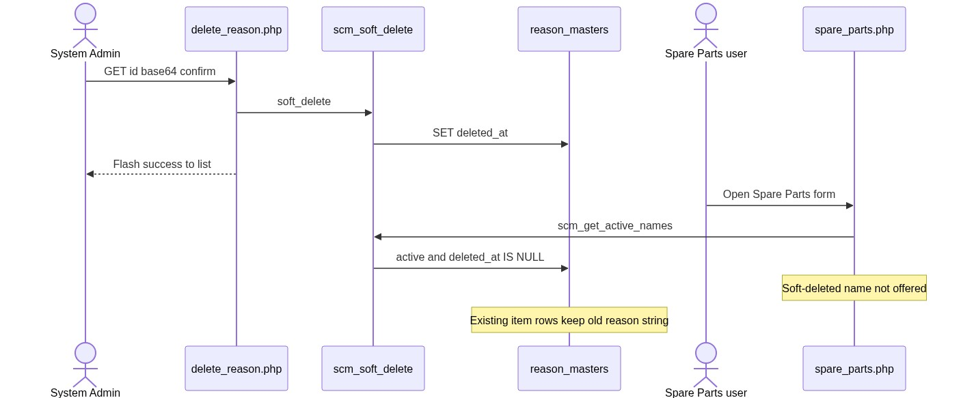
Figure 6 — Sequence: Soft-delete and Spare Parts impact
â”€â”€â”€â”€â”€â”€â”€â”€â”€â”€â”€â”€â”€â”€â”€â”€â”€â”€â”€â”€â”€â”€â”€â”€â”€â”€â”€â”€â”€â”€â”€â”€

11. Activity Diagram
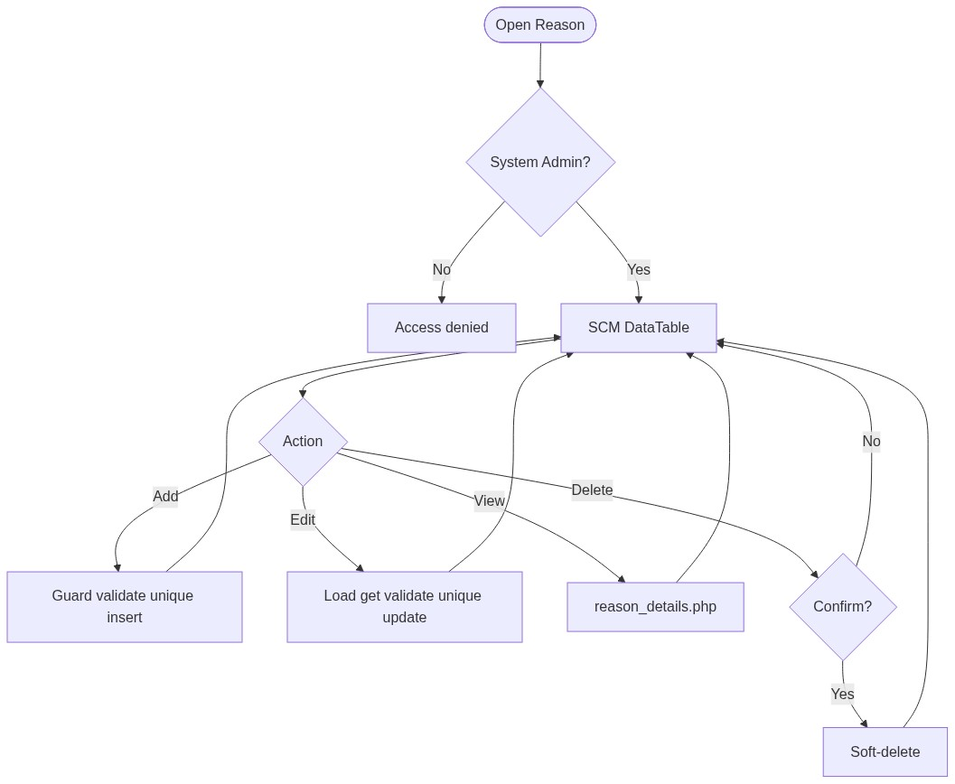
Figure 7 — Activity diagram
â”€â”€â”€â”€â”€â”€â”€â”€â”€â”€â”€â”€â”€â”€â”€â”€â”€â”€â”€â”€â”€â”€â”€â”€â”€â”€â”€â”€â”€â”€â”€â”€

12. Class / Module Diagram
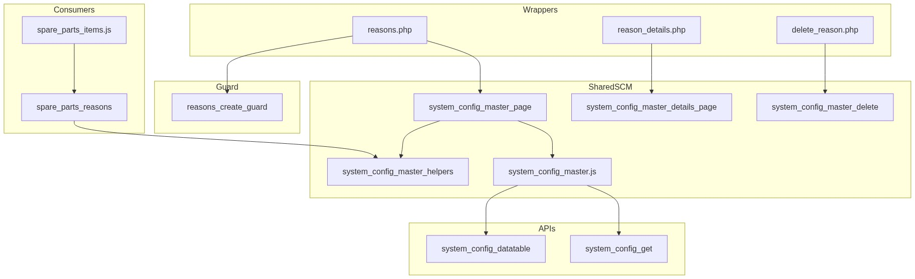
Figure 8 — Class / module diagram

12.1 Key functions
Function | Role
scm_registry / scm_config | Type → table/pages/labels
scm_safe_table | Whitelist table name
scm_from_post / scm_validate | Parse + validate
scm_name_exists | Uniqueness
scm_insert / scm_update / scm_soft_delete | Persist
scm_get_by_id / scm_get_active_names / scm_option_exists | Reads
scm_entry_actions / scm_page_js_config | UI/API wiring
reasons_enforce_create_request | Create abuse guard
spare_parts_reasons | SP active-name options
require_system_admin | Access gate

â”€â”€â”€â”€â”€â”€â”€â”€â”€â”€â”€â”€â”€â”€â”€â”€â”€â”€â”€â”€â”€â”€â”€â”€â”€â”€â”€â”€â”€â”€â”€â”€

13. Folder Structure
ComplaintManagement/
├── reasons.php
├── reason_details.php
├── delete_reason.php
├── api/
│ ├── system_config_datatable.php
│ └── system_config_get.php
├── includes/
│ ├── system_config_master_helpers.php
│ ├── system_config_master_page.php
│ ├── system_config_master_details_page.php
│ ├── system_config_master_delete.php
│ ├── spare_parts_helpers.php
│ ├── admin_access_helpers.php
│ ├── admin_api_guard.php
│ └── module_create_guards/
│ └── reasons_create_guard.php
├── js/
│ ├── system_config_master.js
│ └── spare_parts_items.js
├── storage/
│ └── request_abuse/reasons/
└── docs/
└── LLD_Reason_Module.md
â”€â”€â”€â”€â”€â”€â”€â”€â”€â”€â”€â”€â”€â”€â”€â”€â”€â”€â”€â”€â”€â”€â”€â”€â”€â”€â”€â”€â”€â”€â”€â”€

14. Error Handling
Layer | Pattern
Create guard fail | $_SESSION['error_message']; POST submit unset
Page POST | Inline / session success or error via SCM page
Delete | Session flash → reasons.php
Details invalid | die('Invalid record.') / die('Reason not found.')
APIs | JSON + HTTP 403/404
Create guard log | storage/request_abuse/reasons/

14.1 Common messages
Message | When
Reason saved successfully. | Create
Reason updated successfully. | Update
Reason deleted successfully. | Soft-delete
Failed to save reason. / Failed to update reason. / Failed to delete reason. | Persist fail
Reason not found or already deleted. | Missing target
Reason name already exists... | Unique violation
Invalid record. | Bad delete id
Access denied. System Admin privileges required. | Non-admin

â”€â”€â”€â”€â”€â”€â”€â”€â”€â”€â”€â”€â”€â”€â”€â”€â”€â”€â”€â”€â”€â”€â”€â”€â”€â”€â”€â”€â”€â”€â”€â”€

15. Security Considerations
Area | Control
Authorization | System Admin hard-gate on SCM pages + APIs
Soft-delete | Excluded from active queries and SP options
Create abuse | Throttle, rate limit, payload size, monitor log
Table safety | scm_safe_table whitelist for datatable SQL
DB uniqueness | Partial unique index on lower(trim(name)) among non-deleted
CSRF | Not implemented on POST or GET delete
Delete method | GET soft-delete — CSRF-friendly; confirm only
PRG | Not used on create/update
Guard order gap | Create guard runs before require_system_admin → non-admins may write throttle/abuse files
Option exists gap | scm_option_exists ignores status → inactive name can pass SP server check if forced in POST
Length mismatch | Master VARCHAR(100) vs item VARCHAR(50)
Denormalized names | Rename/delete orphans historical item reason values

â”€â”€â”€â”€â”€â”€â”€â”€â”€â”€â”€â”€â”€â”€â”€â”€â”€â”€â”€â”€â”€â”€â”€â”€â”€â”€â”€â”€â”€â”€â”€â”€

16. Audit Logs

16.1 Built-in field-level audit
Field | Behavior
created_by / created_at | On create
updated_at | On update / soft-delete
deleted_at | Soft-delete
Dedicated audit table | Not implemented
Create abuse log | storage/request_abuse/reasons/abuse_monitor.log

â”€â”€â”€â”€â”€â”€â”€â”€â”€â”€â”€â”€â”€â”€â”€â”€â”€â”€â”€â”€â”€â”€â”€â”€â”€â”€â”€â”€â”€â”€â”€â”€

17. Test Cases

17.1 Functional
ID | Scenario | Expected
TC-01 | Non-admin opens Reason | Denied
TC-02 | Create with empty name | Validation error
TC-03 | Create duplicate name (different case) | Rejected (app + DB unique)
TC-04 | Soft-delete then recreate same name | Allowed
TC-05 | Set status inactive | In admin list; not in SP Select2
TC-06 | Soft-delete name used on SP items | Items keep old string; dropdown omits it
TC-07 | Edit via pencil | Form filled from system_config_get
TC-08 | Delete confirmed | Soft-deleted; flash success
TC-09 | Create twice within 3 seconds | Throttle error
TC-10 | Create >20 in 15 minutes | Rate-limit error
TC-11 | Spare Parts item without reason | Spare part item N: Reason is required.
TC-12 | Spare Parts item unknown reason | Spare part item N: Invalid Reason selected.
TC-13 | Name longer than 50 chars | May save on master but truncate/fail risk on items
TC-14 | Datatable type=reason as admin | Rows from reason_masters
TC-15 | SL / IB Add Spare Parts modal | Reason Select2 loaded from same active names

â”€â”€â”€â”€â”€â”€â”€â”€â”€â”€â”€â”€â”€â”€â”€â”€â”€â”€â”€â”€â”€â”€â”€â”€â”€â”€â”€â”€â”€â”€â”€â”€

18. Assumptions & Dependencies

18.1 Assumptions
1. Role id 6 is System Admin.
2. Soft-delete is the only remove mechanism.
3. Spare Parts Consumption (including SL / IB SP modals) is the only runtime consumer.
4. Operational practice keeps option names ≤ 50 characters to match item column length.
5. Name string denormalization on items is intentional for historical display.
6. Shared SCM stack remains the implementation vehicle.
7. Document target stack Core PHP + MySQL; repo runs PostgreSQL.
8. Create-guard storage under storage/request_abuse/reasons/ is writable.

18.2 Dependencies
Dependency | Purpose
SCM shared pages/helpers/JS/APIs | CRUD UI and persistence
admin_access_helpers / admin_api_guard | System Admin gate
rbac_helpers | Status options / validation / badges
Create-guard storage | Throttle state + abuse log
jQuery + DataTables + validate.js | List / form UX
Spare Parts module | Consumer of active names per line item

â”€â”€â”€â”€â”€â”€â”€â”€â”€â”€â”€â”€â”€â”€â”€â”€â”€â”€â”€â”€â”€â”€â”€â”€â”€â”€â”€â”€â”€â”€â”€â”€

Appendix A — Success flashes
Event | Message
Create | Reason saved successfully.
Update | Reason updated successfully.
Delete | Reason deleted successfully.

â”€â”€â”€â”€â”€â”€â”€â”€â”€â”€â”€â”€â”€â”€â”€â”€â”€â”€â”€â”€â”€â”€â”€â”€â”€â”€â”€â”€â”€â”€â”€â”€

Appendix B — Select2 control map
Screen | Control | Select2?
Admin status select | Native <select> | No
Spare Parts .spare-parts-reason-select | Select2 | Yes (consumer)
SL / IB SP modal reason selects | Select2 | Yes (consumer)

â”€â”€â”€â”€â”€â”€â”€â”€â”€â”€â”€â”€â”€â”€â”€â”€â”€â”€â”€â”€â”€â”€â”€â”€â”€â”€â”€â”€â”€â”€â”€â”€

Appendix C — SCM registry entry
Key | Value
Type | reason
Table | reason_masters
Label | Reason
Plural | Reason Masters
Page | reasons.php
Submit key | submit_reason
Icon | bi-list-check

â”€â”€â”€â”€â”€â”€â”€â”€â”€â”€â”€â”€â”€â”€â”€â”€â”€â”€â”€â”€â”€â”€â”€â”€â”€â”€â”€â”€â”€â”€â”€â”€

Appendix D — Create guard limits
Limit | Value
Max records per request | 1
Min interval between creates | 3 seconds
Max creates per window | 20
Window | 15 minutes

â”€â”€â”€â”€â”€â”€â”€â”€â”€â”€â”€â”€â”€â”€â”€â”€â”€â”€â”€â”€â”€â”€â”€â”€â”€â”€â”€â”€â”€â”€â”€â”€

Appendix E — Status vs consumer visibility
Value | Admin list | Spare Parts options
active | Yes | Yes
inactive | Yes | No
Soft-deleted | No | No

â”€â”€â”€â”€â”€â”€â”€â”€â”€â”€â”€â”€â”€â”€â”€â”€â”€â”€â”€â”€â”€â”€â”€â”€â”€â”€â”€â”€â”€â”€â”€â”€

Appendix F — Consumer column map
Module | Column | Max length
Spare Parts items | spare_parts_consumption_items.reason | 50
Master | reason_masters.name | 100

â”€â”€â”€â”€â”€â”€â”€â”€â”€â”€â”€â”€â”€â”€â”€â”€â”€â”€â”€â”€â”€â”€â”€â”€â”€â”€â”€â”€â”€â”€â”€â”€
End of LLD — Reason Module

